# **Compare models with vs without random slope**

Determine whether we add random slopes

model1 <- lmer(reading_time ~ paragraph_type*is_dyslexic + (1+paragraph_type+is_dyslexic|subject), data = data,)

model2 <- lmer(reading_time ~ paragraph_type*is_dyslexic + (1|subject), data=data,)

anova(model1, model2)

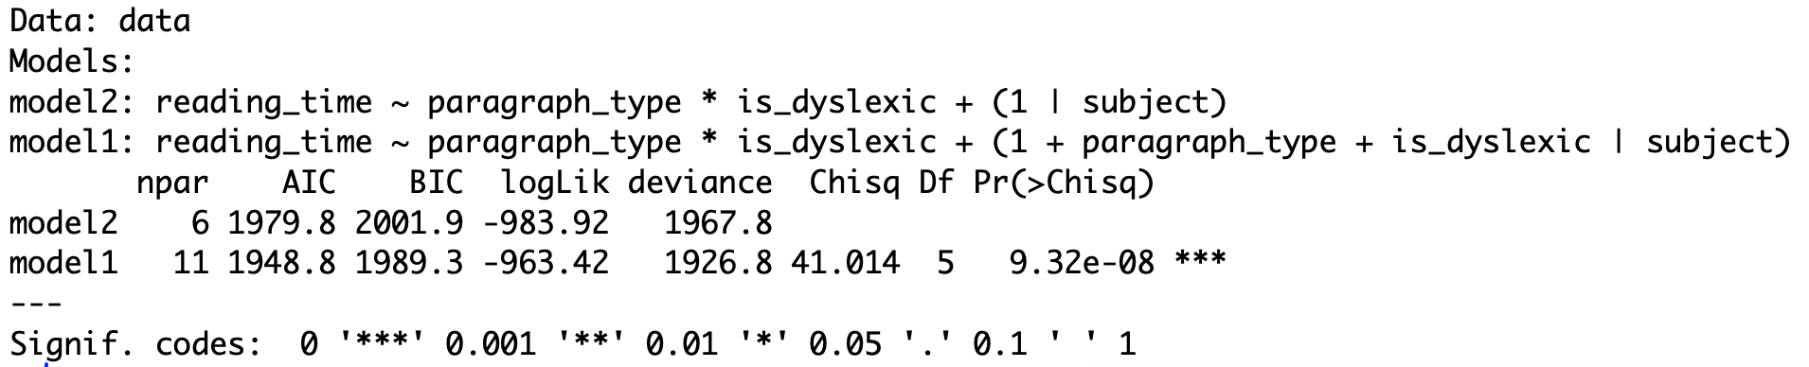

In this case, model1 with 11 parameters has a lower AIC and BIC compared to model2, which would typically indicate that model1 fits the data better.

The p-value indicates the significance of the difference between the two models. A value less than 0.05 suggests a significant difference, meaning that the more complex model (model1) significantly better fits the data than the simpler model (model2) does.

# **Results regarding reading_time**

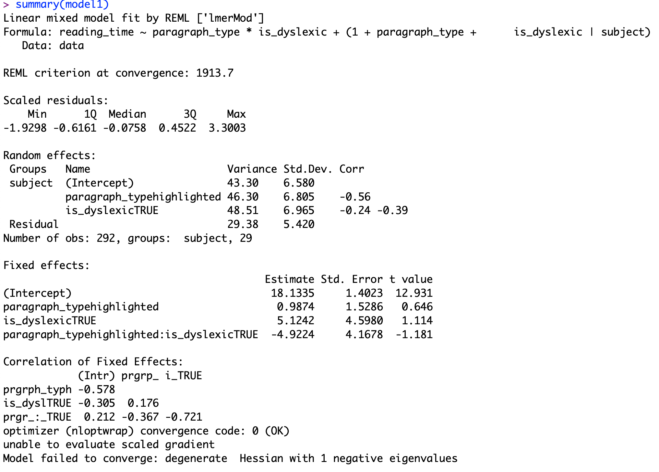

# **Results regarding error rate.**

